Output Voltage Ripple Calculation for Worst Case (Minimum Input Voltage, Maximum Load)

$$∆V=48*0.03=1.44V ∆Q=C ∆V$$

$$\frac{I_{out} ∆t}{C}=\frac{I_{out} D T_{s}}{C}=∆V$$

$$C_{out}=\frac{1*0.5}{60*{10}^{3}*1.44}=5.78 μF$$

**Note:** To keep the voltage less reactive during sudden load changes, we will be using an output capacitor $C_{out}=47 uF$. Choosing these values ensures that we both satisfy the output voltage ripple constraint and regulation constraint.

RCD Snubber Calculation

Let $V_{snub}=2.5 V_{in}=30V$

$$I_{pri_max}=I_{pri_avg}+\frac{1}{2}I_{ripple}=\frac{\left(Vout+V_{f}\right)I_{out}}{V_{in} f_{s} D T_{s}}+\frac{V_{in} D T_{s}}{2 L_{pri}}=\frac{\left(48+0.7\right)*1}{12*60*{10}^{3}*0.5*\frac{1}{60*{10}^{3}}}+\frac{12*0.5}{2*13*{10}^{-6}*60*{10}^{3}}=12 A$$

Let ${ΔV}_{snub}=0.1 V_{snub}=3V$

$$ΔV_{snub}=\frac{V_{snub}}{C_{snub}*R_{snub}*f_{s}}$$

$$3=\frac{30}{C_{snub}*R_{snub}*60*{10}^{3}} => C_{snub}=\frac{30}{3*480*60*{10}^{3}}=347 nF$$

$$R_{sn}=\frac{V_{snub}^{2}}{\frac{1}{2}L_{leak}*i_{peak}^{2}*\frac{V_{snub}}{V_{snub}-V_{in}}*f_{s}}$$

$$R_{snub}=\frac{V_{snub}^{2}}{\frac{1}{2}13*{10}^{-6}*0.02*{12}^{2}*\frac{30}{30-12}*60*{10}^{3}}=480 Ω (Assumed leakage inductance is \%2)$$

RC Snubber Calculation

In calculating the RC snubber for the secondary side diode, procedure in [2] was followed.

Oscillation frequency: $f_{0}=10MGhz$

Shifted oscillation frequency $f_{1}=4MGhz$ with parallel capacitor $C_{1}=1000pF$

Snubber resistor $R_{snub}=83.56Ω$, snubber capacitor $C_{snub}=571.43pF$

**Note:** In order to optimize the losses and reduce the peak oscillation voltage and frequency to a desired value, the final values of the components were changed as follows:

$R_{snub}=100Ω$, $C_{snub}=330pF$

Design decisions

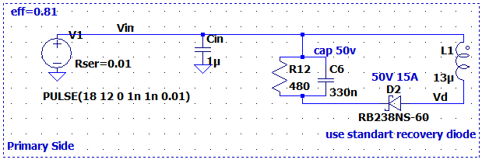

-Since our power specification is 1W, it is reasonable to choose $C_{in}=1 μF$

-The RCD snubber components are chosen regarding the section before.

-The snubber diode is chosen so that it can supply the average snubber current and peak oscillation currents.

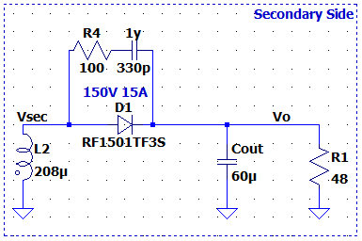

-Since there are no 60 uF capacitors available commercially, we opted to include an output capacitor .

- The RC snubber components are chosen regarding the section before.

-The output diode will be able to withstand peak currents of the oscillations and the average output current.

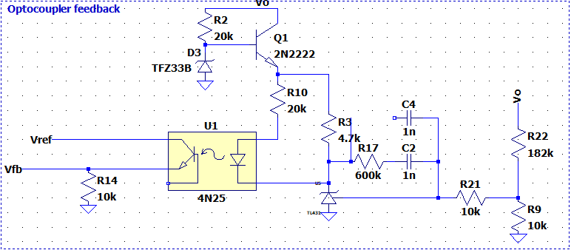

-TL431 Adjustable Voltage Reference is used to provide feedback from the output voltage. Since it can achieve 2.5V at the reference pin, we can reflect that voltage to the output using a voltage divider network. Since the maximum operating voltage of TL431 is 37V, a linear regulator is implemented with a 30 Zener diode to protect the component. Because this stage is not a power stage, the power loss from the linear regulator is negligible.

-4N25 optocoupler is used because it is included in the LTSpice library. The resistors are connected to the optocoupler anode adjusts the controller parameters, so it is chosen such that is slows down the response. A 4.7k resistor is connected in order to protect the component.

-TL431 component is used as a PI controller in this stage. The parameters of the controller is adjusted so that the regulation constraints are satisfied. In this resistor and capacitor configuration, the converter satisfied these requirements. If required, a compensation capacitor can be adde to the controller to slow down the response.

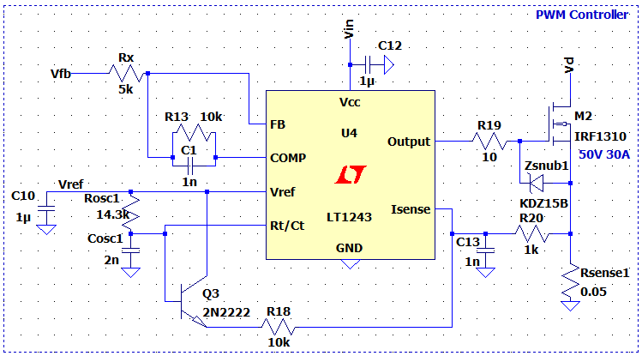

-For our controller IC, we opted to use UC 3843 Current Mode PWM Controller(LT1243 is pin to pin equivalent of this IC in LTSpice) because of its current mode abilities. It includes a gate driver for the MOSFET and can operate up to %100 duty cycle (Although our maximum duty cycle is %50).

-Since we are operating at 60kHz frequency, our $R_{osc} and C_{osc}$ values were chosen accordingly to set the oscillator frequency inside the PWM controller.

-A protection Zener diode is used to protect the MOSFET $V_{GS}$ from voltage spikes. Additionally, A 10R resistor is used to limit the charging currents of the MOSFET capacitors.

-1μF bypass capacitors are used to supply a reasonably constant input and reference voltage to and from the IC.

-To use the current mode capability of the IC, we will be using a 50mΩ sense resistor to measure the primary current. To supply a noise-free voltage $I_{sense}$ pin of the controller, a low-pass filter is implemented on the sensed voltage. Additionally, a slope compensation network is implemented to reduce the voltage spikes in the waveform.

-The controller parameters of the controller are determined by trial and error and the resistor and capacitor values are chosen to provide adequate Kp and Ki values.

Simulation Results

The simulations are conducted with $f_{s}=60kHz$, ${ V}_{in}=12V,$ $R_{load}=48Ω$



*Figure XX. Waveforms for $V_{pri},V_{DS},I_{pri}$ respectively for ideal case*



*Figure XX. Waveforms for $V_{o},V_{sec},I_{diode}$ respectively for ideal case*



*Figure XX. Waveforms for $I_{pri},V_{DS},V_{pri}$ respectively for non-ideal case (No RCD snubber)*



*Figure XX. Waveforms for ${V_{sec},V}_{o},I_{diode}$ respectively for non-ideal case (No RCD snubber)*



*Figure XX. Waveforms for $I_{pri},V_{DS},V_{pri}$ respectively for non-ideal case (With RCD snubber)*



*Figure XX. Waveforms for ${V_{sec},I_{diode},V}_{o}$ respectively for non-ideal case (With RCD snubber)*

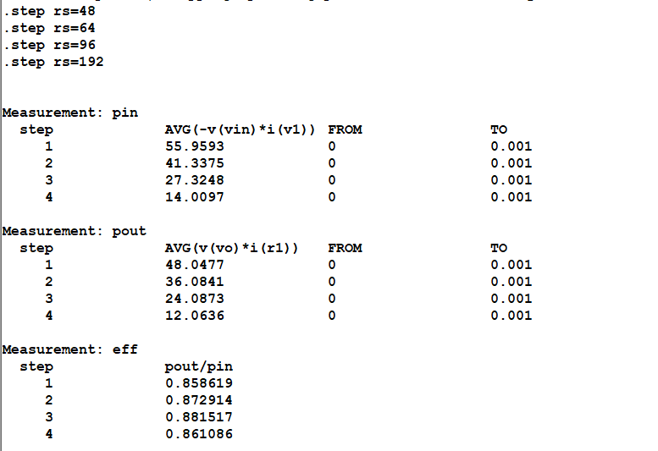

*Figure XX. Efficiency at %100, %75, %50, %25 loads.*

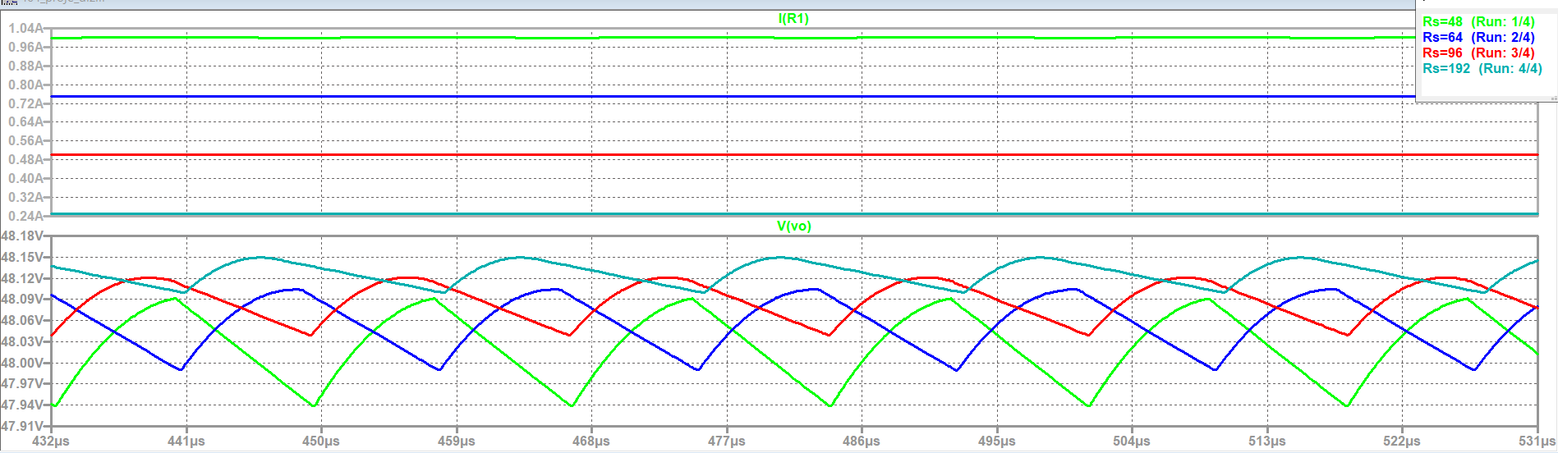

*Figure XX. Output Voltage and Current waveforms at %100, %75, %50, %25 loads*

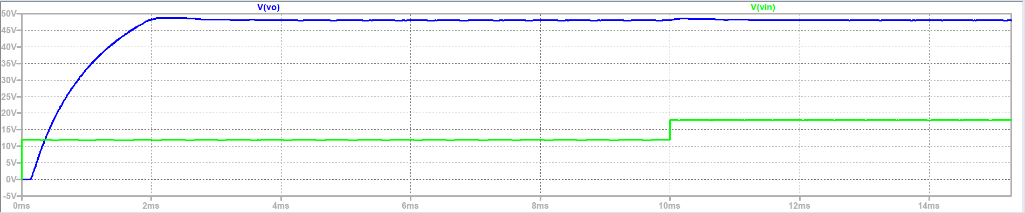

*Figure XX. Output and Input Voltage waveforms for Low Input Voltage to High Input Voltage Situation*



*Figure XX. Output Voltage waveform for %100 Load to %10 Load Condition*

References

1. “Application Note AN-4147 Design Guidelines for RCD Snubber of Flyback Converters,” 2006. [Online]. Available: https://e2e.ti.com/cfs-file/__key/communityserver-discussions-components-files/196/Design-Guidelines-for-RCD-Snubber-of-Flyback-Converters_2D00_Fairchild-AN4147.pdf. [Accessed: 05-May-2023].
2. J. Betten, “Power tips: Calculate an R-C snubber in seven steps,” *Power management - Technical articles - TI E2E support forums*, 05-May-2016. [Online]. Available: https://e2e.ti.com/blogs_/b/powerhouse/posts/calculate-an-r-c-snubber-in-seven-steps. [Accessed: 05-May-2023].
3. T. H. Chen, W. L. Lin and C. M. Liaw, "Dynamic modeling and controller design of flyback converter," in IEEE Transactions on Aerospace and Electronic Systems, vol. 35, no. 4, pp. 1230-1239, Oct. 1999, doi: 10.1109/7.805441.
4. R. Sheehan, “Understanding and applying current-mode control theory ,” 31-Oct-2007. [Online]. Available: https://www.ti.com/lit/an/snva555/snva555.pdf. [Accessed: 05-May-2023].